Jan Liska has given me a new app to post. It’s called Property Review and it lets you compare properties across multiple file versions. Jan also wrote Drawing Compare, so I’m starting to see a pattern here.
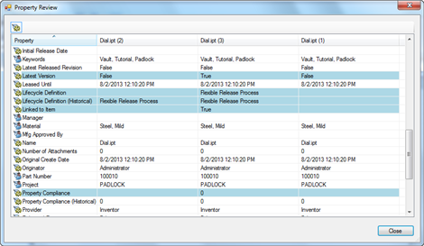
(click image for full view)

Requirements:
Vault Workgroup or Professional 2014
Click here to download the application
Click here to download the source code
As with all the samples on this site, the legal disclaimer applies.

